OS Assignment-08

Jeetu Mehra
U24AI032

Question 1 : To Write a C program to simulate producer-consumer problem using semaphores.
Code:
#include<stdio.h>
#include<stdlib.h>
#include<pthread.h>
#include<semaphore.h>

#define BUFFER_SIZE 5

int buffer[BUFFER_SIZE];
int in = 0, out = 0;

sem_t empty, full, mutex;

void* producer(void* arg)
{
int item;

for(int i=0;i<10;i++)
{
item = rand()%100;

sem_wait(&empty);
sem_wait(&mutex);

buffer[in] = item;
printf("Produced: %d\n",item);
in = (in+1)%BUFFER_SIZE;

sem_post(&mutex);
sem_post(&full);
}

return NULL;
}

void* consumer(void* arg)
{
int item;

for(int i=0;i<10;i++)
{
sem_wait(&full);
sem_wait(&mutex);

item = buffer[out];
printf("Consumed: %d\n",item);
out = (out+1)%BUFFER_SIZE;

sem_post(&mutex);
sem_post(&empty);
}

return NULL;
}

int main()
{
pthread_t p,c;

sem_init(&empty,0,BUFFER_SIZE);
sem_init(&full,0,0);
sem_init(&mutex,0,1);

pthread_create(&p,NULL,producer,NULL);
pthread_create(&c,NULL,consumer,NULL);

pthread_join(p,NULL);
pthread_join(c,NULL);

return 0;
}

}

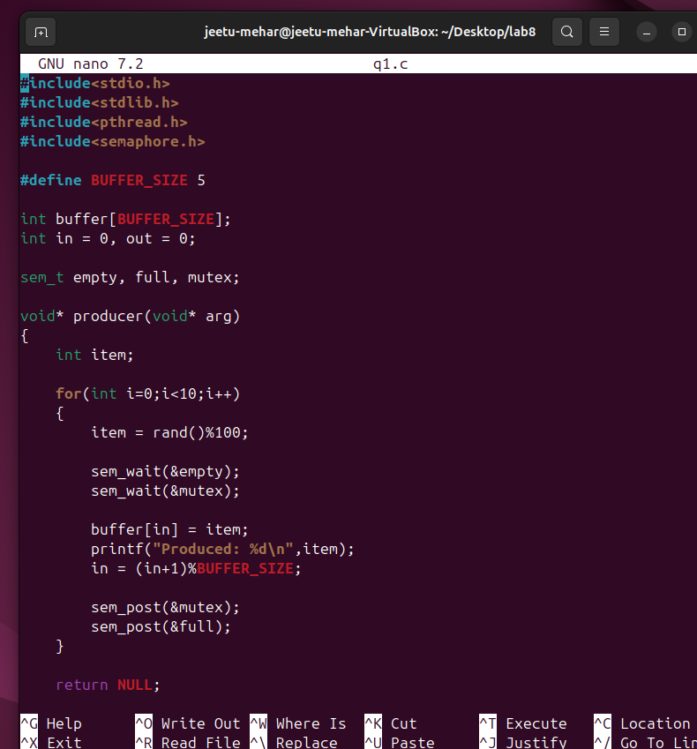

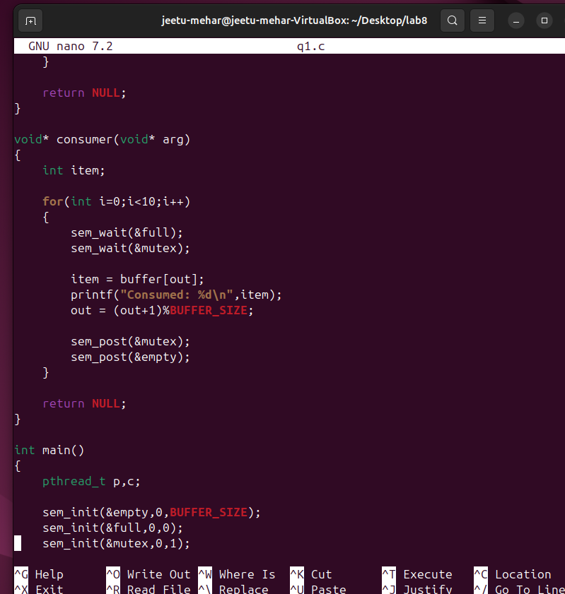
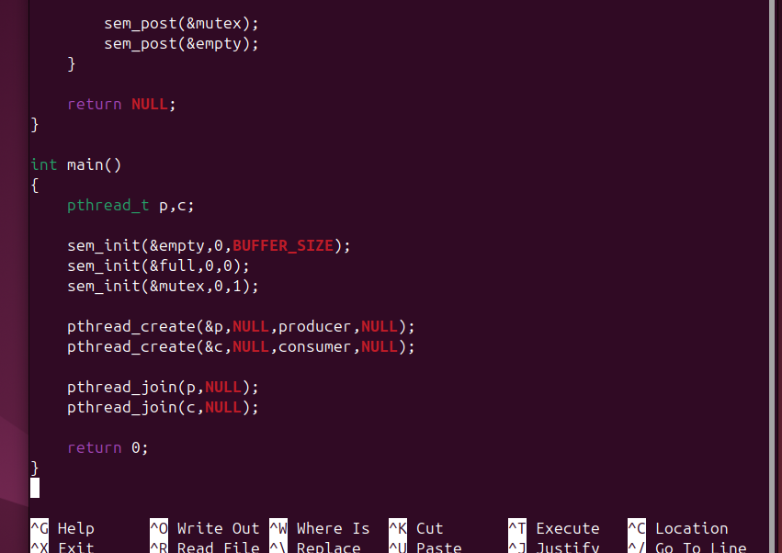

Output:
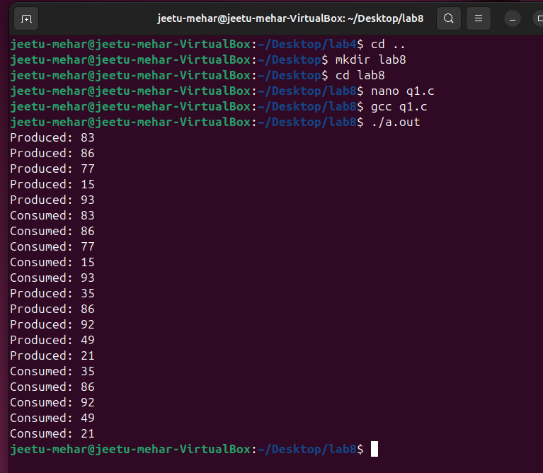

Question 2 : Write a C program to simulate the concept of Dining-Philosophers problem.
Code:
#include<stdio.h>
#include<pthread.h>
#include<semaphore.h>
#include<unistd.h>

#define N 5

sem_t chopstick[N];

void* philosopher(void* num)
{
int id = *(int*)num;

while(1)
{
printf("Philosopher %d is thinking\n",id);
sleep(1);

sem_wait(&chopstick[id]);
sem_wait(&chopstick[(id+1)%N]);

printf("Philosopher %d is eating\n",id);
sleep(1);

sem_post(&chopstick[id]);
sem_post(&chopstick[(id+1)%N]);
}
}

int main()
{
pthread_t ph[N];
int id[N];

for(int i=0;i<N;i++)
sem_init(&chopstick[i],0,1);

for(int i=0;i<N;i++)
{
id[i]=i;
pthread_create(&ph[i],NULL,philosopher,&id[i]);
}

for(int i=0;i<N;i++)
pthread_join(ph[i],NULL);

return 0;
}

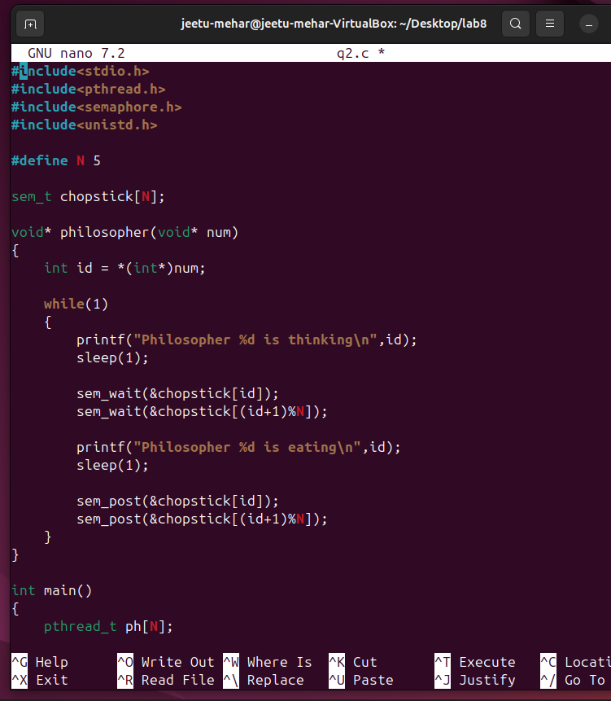

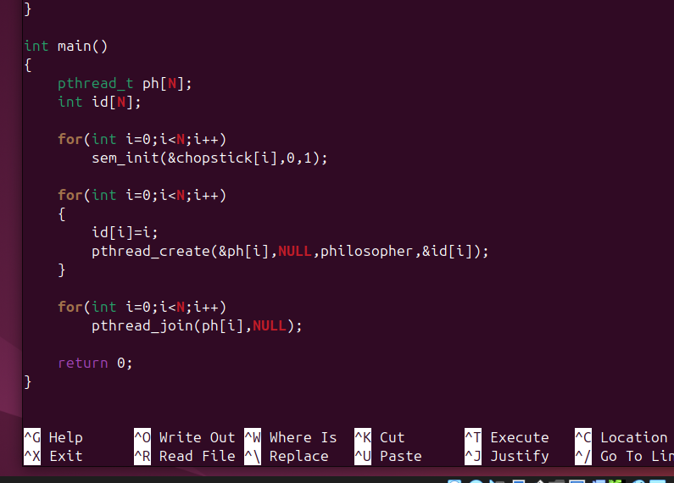

Output:
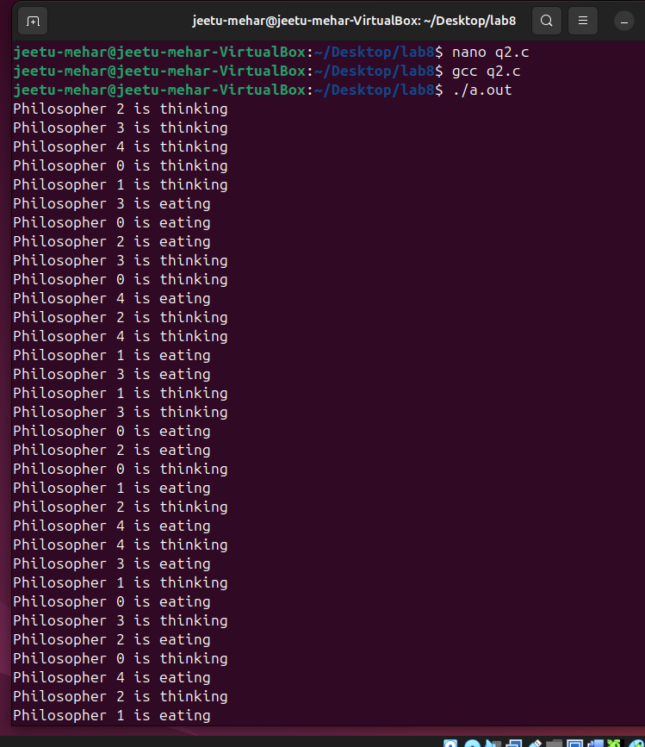

Question 3 : Write a C program to simulate the concept of Readers-Writers problem.
Code:
#include<stdio.h>
#include<pthread.h>
#include<semaphore.h>

sem_t mutex, wrt;
int readcount = 0;
int data = 0;

void* reader(void* arg)
{
sem_wait(&mutex);
readcount++;

if(readcount==1)
sem_wait(&wrt);

sem_post(&mutex);

printf("Reader reads data = %d\n",data);

sem_wait(&mutex);
readcount--;

if(readcount==0)
sem_post(&wrt);

sem_post(&mutex);

return NULL;
}

void* writer(void* arg)
{
sem_wait(&wrt);

data++;
printf("Writer writes data = %d\n",data);

sem_post(&wrt);

return NULL;
}

int main()
{
pthread_t r[3], w[2];

sem_init(&mutex,0,1);
sem_init(&wrt,0,1);

for(int i=0;i<3;i++)
pthread_create(&r[i],NULL,reader,NULL);

for(int i=0;i<2;i++)
pthread_create(&w[i],NULL,writer,NULL);

for(int i=0;i<3;i++)
pthread_join(r[i],NULL);

for(int i=0;i<2;i++)
pthread_join(w[i],NULL);

return 0;
}
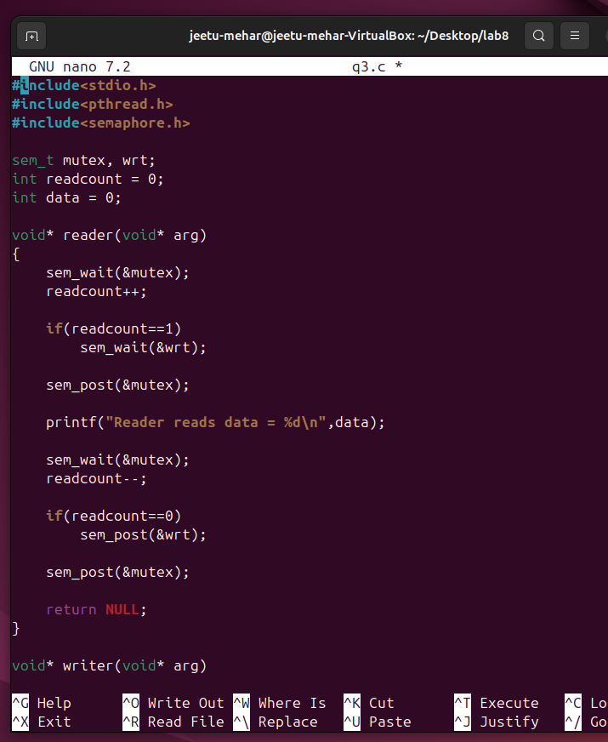
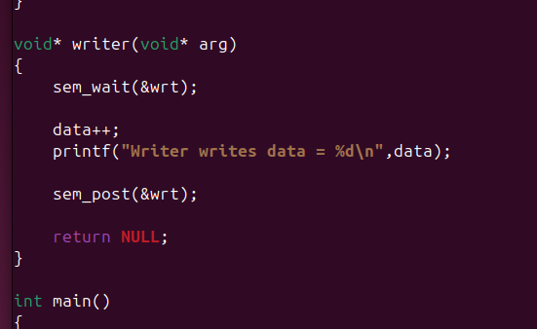
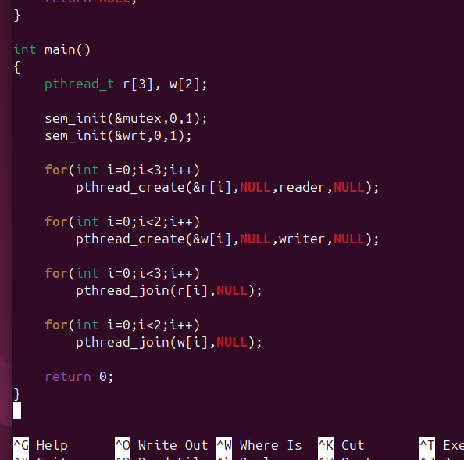

Output:
